

POLYTECHNIC UNIVERSITY OF THE PHILIPPINES
Lopez, Quezon Branch
Lopez, Quezon



PEDIACARE CLINIC DATABASE SYSTEM

In final requirements for
INFORMATION MANAGEMENT

by:

SHIELO MARIE C. CLEOFE
JONELL L. SANTOS
BSIT 2-1

July 27, 2022
I. Project Context
PediaCare Clinic is a Pediatric Database File that is developed using Microsoft Access Application which contains the following data such as Patient/Client Record, Pediatrician record, Procedure record, visitation record and Invoice or Receipt record of a patient. It is an information database record of a patient for the convenient record of a pediatric clinic. It was developed and designed due to necessity since there are no existing pediatric clinic in our place. It also provides on hand information about the record of the patient together with the record of the attending pediatrician. The aim of this database is to manage the existing and previous record of the patients to minimize the time consuming in finding the record of a particular patient. With the used of this database, it will provide a quick-time access to the needing file since it is already recorded in the database system of our clinic. The data contains the name of the patient who have undergo some procedure and tells the status of the patients as well as the availability of the attending pediatrician. Therefore, the PediaCare Clinic database was designed because previously the task of handling the patient record is very difficult.

II. Scope and Constraints
The person who will be benefited by this database is the patients and the attending pediatrician of the clinic. PediaCare Clinic Database System allow you to manage the record, processes, and workflows with features such as adding/creating patient record, searching patient record or form, save patient record, open the main form from the specific form and storing patient-related information and pediatrician record. It enables the attending pediatrician and the owner of the clinic to streamline the workflow of the clinic including the schedule of the pediatrician and the visiting time of the patient in the clinic This PediaCare Database Clinic will assure the patient that their data information is secured and confidential. It includes access control to the recorded information, record of procedure, and history of illness of the patient as well as the visiting time of the customer and other statistical reports like receipt or invoice.
The constrain of this database in terms of scheduling, patients would not be able to set their schedules online since this database focuses only for the record of the patients, pediatricians, procedures, and visitations of the said pediatric clinic. Furthermore, this database system cannot hold infinite amount of data because of the storage limitations of the Microsoft Access Software.

III. Benefits and Impacts
An important benefit provided by PediaCare Clinic Database is the improvement of data handling of patient record, which results in a better assistance of a patients. Specially if they have any concern and what to clarify something they reach the clinic easily because the clinic will provide a receipt that contains the number of attending pediatrician together with the address of the clinic. It also gives ease to the attending pediatrician when finding the patient record because they can access it easily in the database system of the clinic.

IV. Design
- E-R Diagram
PetCare Entity Relationship Diagram
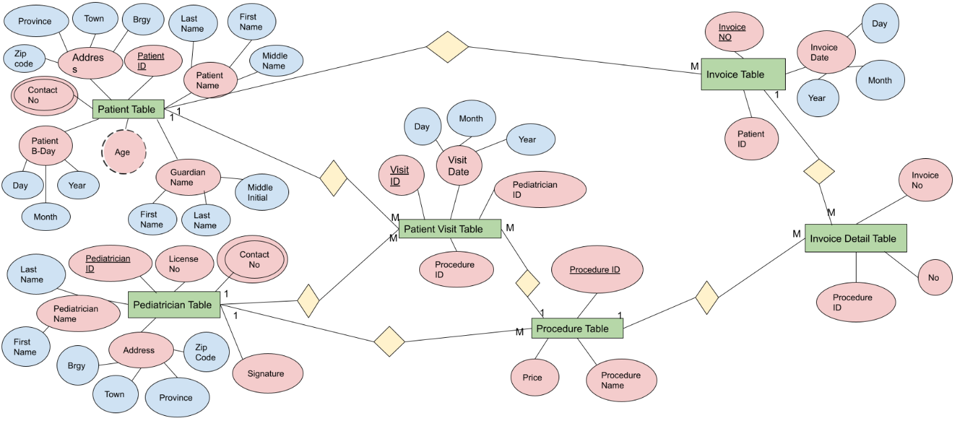
Figure 1. It shows the relationship of each entity.

- Main Form

Figure 2. It shows the main form of the database.

- Forms
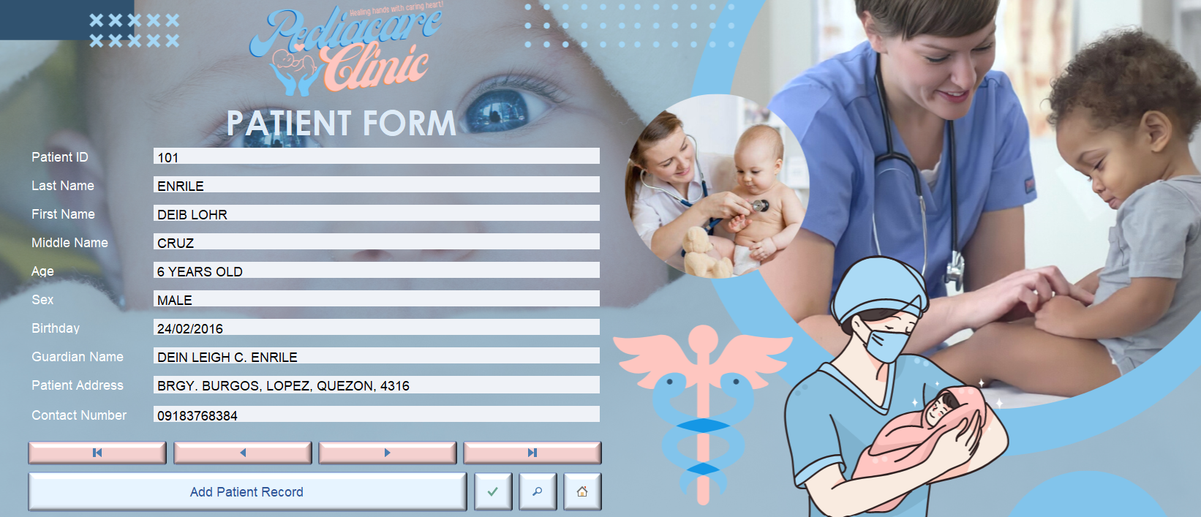Figure 3. It shows the patient form of the database.
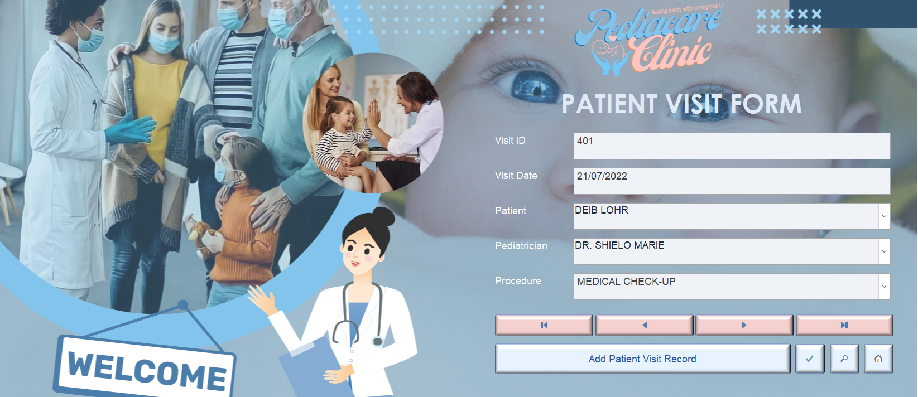Figure 4. It shows the patient visit form of the database.

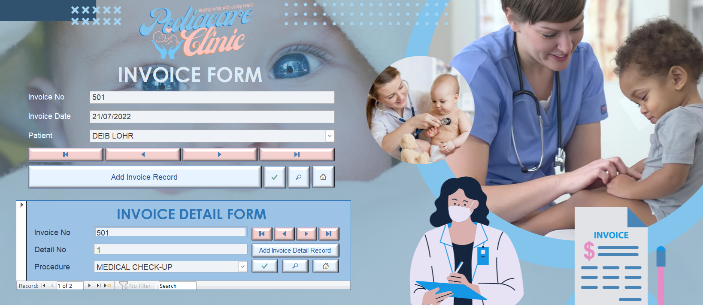
Figure 5. It shows the invoice and invoice detail form of the database.
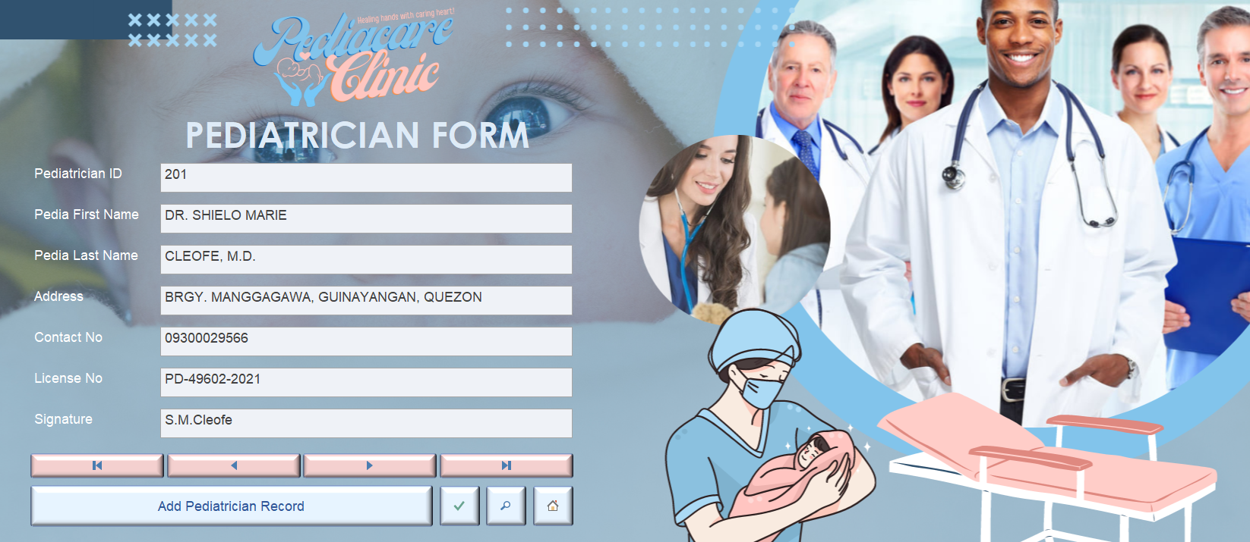
Figure 6. It shows the pediatrician form of the database.
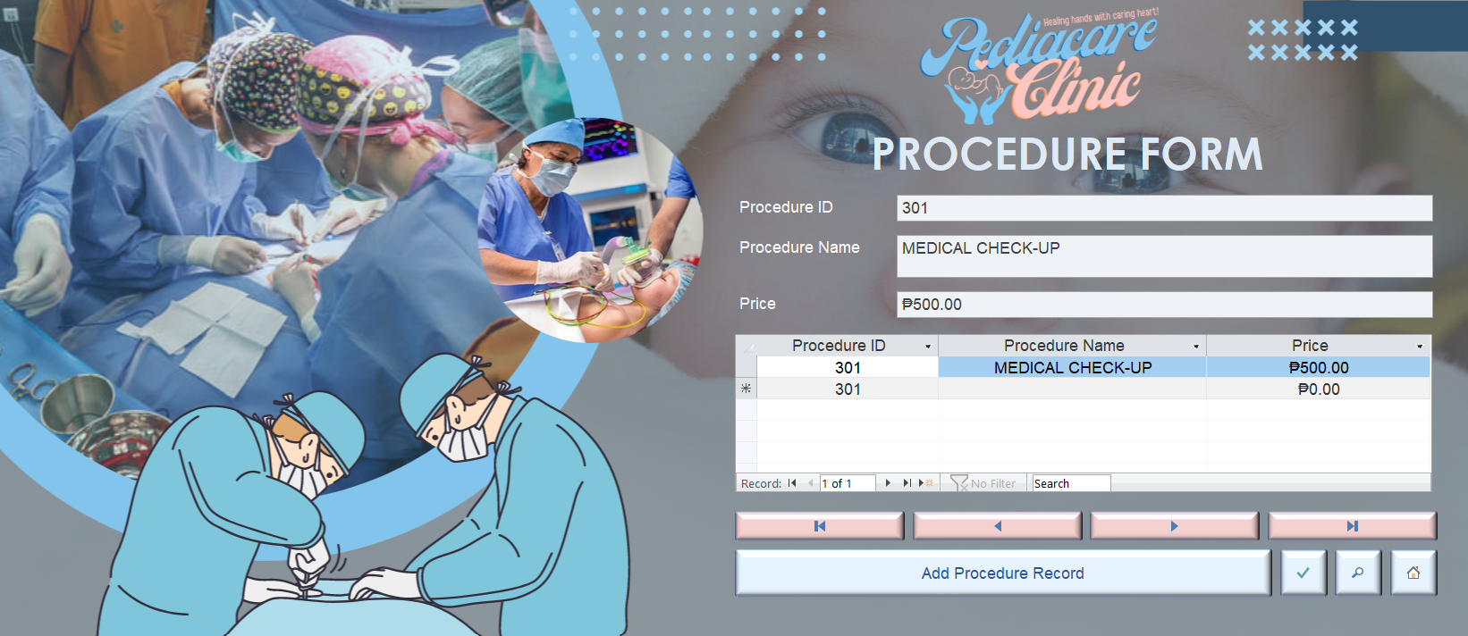
Figure 7. It shows the procedure form of the database.

- Reports – requirement Receipt other reports
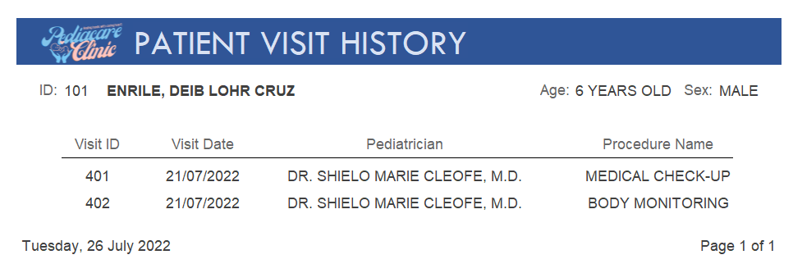
Figure 8. It shows the patient visit history of the database with a parameter ‘Patient ID’.
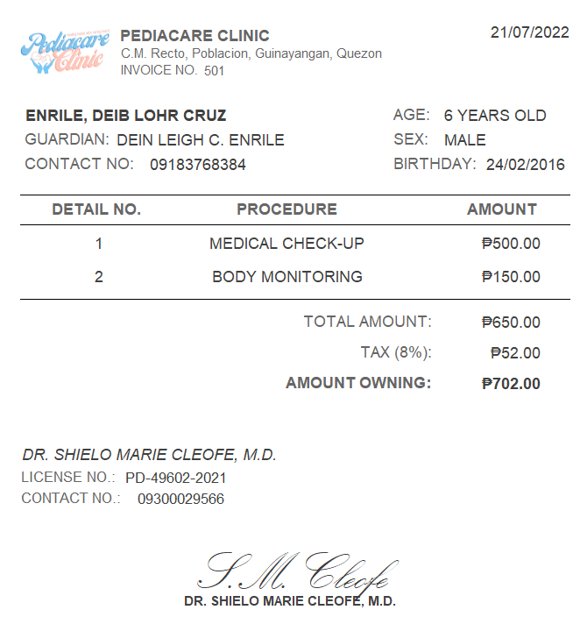
Figure 9. It shows invoice report of the database with a parameter of ‘Invoice No’
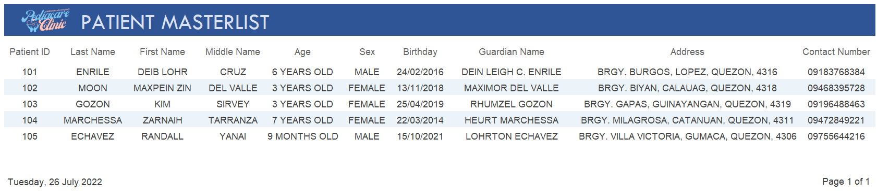
Figure 10. It shows the patient master list of the database.
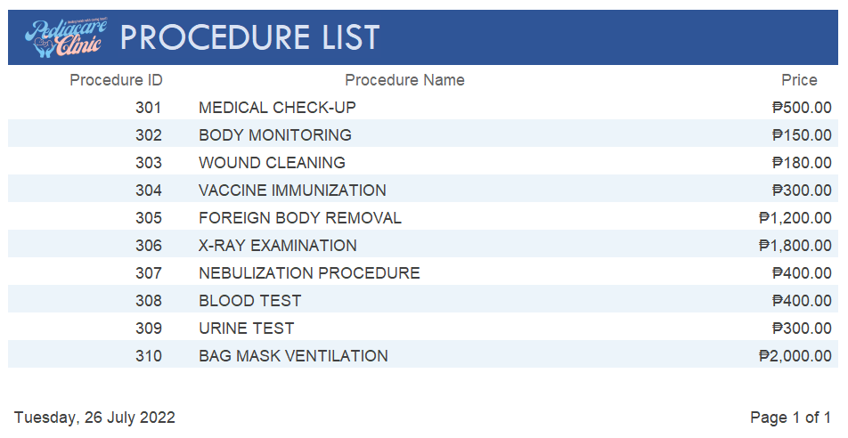
Figure 11. It shows the procedure list of the database.

